

Schools must use the funding to make additional and sustainable improvements to the quality of PE and sport they offer. This means that you should use the Primary PE and Sport Premium to:

- develop or add to the PE and sport activities that your school already offers
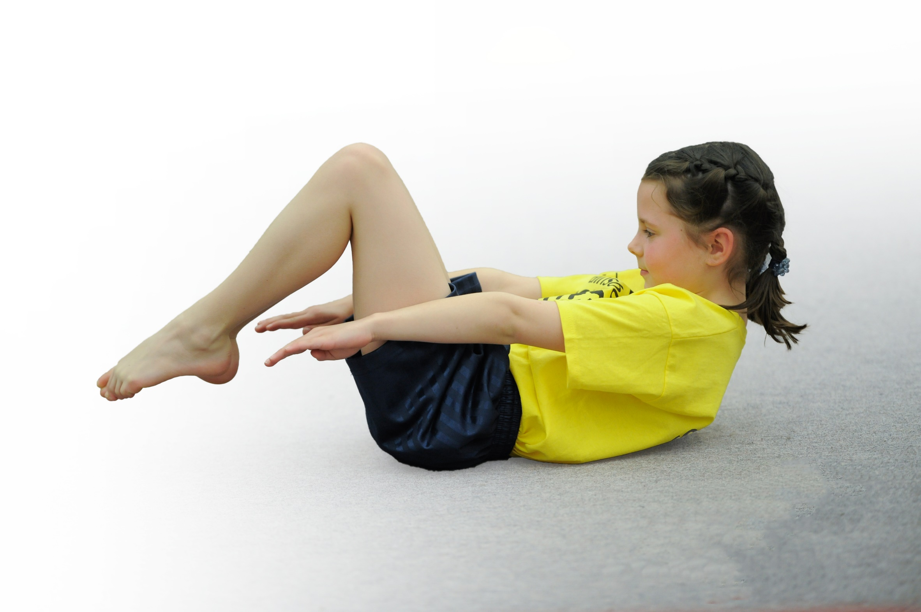
- build capacity and capability within the school to ensure that improvements made now will benefit pupils joining the school in future years

Please visit gov.uk for the revised DfE guidance including the 5 key indicators across which schools should demonstrate an improvement. This document will help you to review your provision and to report your spend. DfE encourages schools to use this template as an effective way of meeting the reporting requirements of the Primary PE and Sport Premium.

We recommend you start by reflecting on the impact of current provision and reviewing the previous spend.
Under the Ofsted Schools Inspection Framework, inspectors will assess how effectively leaders use
the Primary PE and Sport Premium and measure its impact on outcomes for pupils, and how effectively governors hold them to account
for this.

Schools are required to publish details of how they spend this funding as well as on the impact it has on pupils’ PE
and sport participation and attainment.
We recommend regularly updating the table and
publishing it on your website as evidence
of your ongoing review into how you are using the money
to secure maximum, sustainable impact. To see an example of how to complete the table please click HERE.

Support for review and reflection - considering the 5 key indicators from DfE, what development needs are a priority for your setting and your students now and why? Use the space below to reflect on previous spend, identify current need and priorities for the future.

Please note that the plan below has not been able to be implemented as planned due to Corona Virus restrictions. We have continued to promote sport, exercise and healthy lifestyles as far as possible. The highlighted sections are areas we have been able to carry out. Any additional funding has been reallocated towards outdoor gym equipment for the KS2 playground, which should be installed by the end of the academic year.

Key achievements to date: | Areas for further improvement and baseline evidence of need:
Bronze and Silver Sainsbury’s School Games Mark.  Sports participation numbers increasing each year throughout school, including Pupil Premium and lower ability children, through offering a greater number of sporting opportunities to all children (increased amount of competitions and clubs since joining Qualitas). We have also offered a broader range of sports to all pupils.  Increased confidence, knowledge and skills of staff teaching PE through attaining Real PE scheme, CPD and team teaching.  Beginning to teach aspects of PE throughout other parts of curriculum, including Science, Maths, Music and PSHE.  An increased appreciation for Dance from pupils following our inter-school Dance competition.  2nd Place in the A league football and 1st Place in the Netball league 2016/17, Basketball Tupton Cluster winners 2017/18, 1st and 2nd in annual Tennis competition against local schools in cluster 2018-19 and 2019-20, 1st Place in Futsal event at EIS Sports Day and 2nd place in Benchball 2018-19, 2nd place in Elite performers competition against cluster schools. | To further improve our results at competitions so that we get into the top 3 schools more frequently.  To continue to increase sporting participation for all children (especially pupil premium and lower ability children) through targeted interventions and increased sporting opportunities, which will hopefully lead to more children prolonging their participation.  To ensure all our students receive at least 30 minutes of physical activity daily through new sporting initiatives at school.  Continue to raise the profile of PE and sport as a tool for whole school improvement.

Meeting national curriculum requirements for swimming and water safety | Please complete all of the below*:
What percentage of your current Year 6 cohort swim competently, confidently and proficiently over a distance of at least 25 metres? | 60%
What percentage of your current Year 6 cohort use a range of strokes effectively [for example, front crawl, backstroke and breaststroke]? | 60%
What percentage of your current Year 6 cohort perform safe self-rescue in different water-based situations? | 40%
Schools can choose to use the Primary PE and Sport Premium to provide additional provision for swimming but this must be for activity over and above the national curriculum requirements. Have you used it in this way? | Yes/No
*Schools may wish to provide this information in April, just before the publication deadline.

Action Plan and Budget Tracking
Capture your intended annual spend against the 5 key indicators. Clarify the success criteria and evidence of impact that you intend to measure to evaluate for students today and for the future.

Academic Year: 2020/21 | Total fund allocated: £18,000  Total spent: | Date Updated: September 2020
Key indicator 1: The engagement of all pupils in regular physical activity – Chief Medical Officer guidelines recommend that primary school children undertake at least 30 minutes of physical activity a day in school |  |  |  | Percentage of total allocation:
 |  |  |  | ???%
School focus with clarity on intended impact on pupils: | Actions to achieve: | Funding allocated: | Evidence and impact: | Sustainability and suggested next steps:
To develop the role of Sports Leaders in school to encourage more children to take part in physical activities at lunch times.  Play Leaders to organise games and activities for children at lunchtime to increase their physical participation during this time. There will be a play leader on both the KS1 and KS2 playgrounds for the entire lunch hour.  Extra-curricular clubs provided at lunch time and after school to engage more children in physical activity and target PP and LA children.  Purchasing the correct equipment which will allow high-quality PE lessons and students to be motivated to take up an activity. | Training of Sports Leaders provided by Qualitas in a 10 week programme. Following training, a schedule for lunchtimes is devised by PE lead and Sports Leaders. A reward system for leaders is used and PE lead ensure it is kept to.  Play leaders ensure equipment is set up and ready for start of lunch. They must ensure activities are varied throughout the week to keep children motivated and engaged.  Target children needed to be identified and targeted for certain clubs to ensure they are engaged in physical activity. Meetings with Qualitas to discuss how clubs are going and any changes needed to increase participation. Lunch staff informed of children having early lunch to maximize time spent being active. Clubs selected based on what children say they want on student questionnaires at start of year.  Equipment needs to be monitored, with old equipment replaced and for new clubs/lunch time staff to have equipment necessary to engage students. | £1000  £2730  1 x 6hours per week.  £5000  £500 | Sports leaders lead an activity twice a week at lunch/break time for 30 minutes and children get involved in physical activity at lunch times.  Children, especially in KS1, are more engaged in physical activity at lunch times. Children noticeably enjoy the games being played.  Targeted children are participating in sport/physical activity for at least 30 minutes and lunch/after school. Many targeted children then take up more sport/physical activity as a result of being at clubs- each class had a sports coach for their 30 minutes outside play session at lunch.  Equipment being used daily in PE lessons and at break/lunch times, encouraging/allowing physical activity to take place.  - | Continue to train all new year 5s to ensure more children have a sense of responsibility at lunch times, encourage current Y6’s to help new sports leaders and to take part in the lunch time activities (to encourage younger year groups to follow role model Y6’s). For next year, introduce buddy system for new Y5 sports leaders with previous leaders.  Continue to vary games lead by PlayLeaders each year, keeping the games they enjoy the most to continue their motivation to stay active. Monitor PlayLeaders when time to ensure effectiveness.  Continue to provide lunch time and after school clubs which target PP/LA children. Continue to plan lunch/after school clubs with Qualitas based on what children want to participate in (taken from whole school questionnaire results). Change/vary any clubs that did not get enough regular participation (e.g. basketball). Looking forward, get qualitas coaches in for specific interventions for LA chn one afternoon a week (start KS1).  Continue to update equipment as and when. Look into improving Gymnastics equipment next to raise profile.  -
Key indicator 2: The profile of PE and sport being raised across the school as a tool for whole school improvement |  |  |  | Percentage of total allocation:
 |  |  |  | %
School focus with clarity on intended impact on pupils: | Actions to achieve: | Funding allocated: | Evidence and impact: | Sustainability and suggested next steps:
Real PE lessons embedded with teachers and children, which has had a positive impact on children’s attitudes to PE.  Notice board in school with sports news on that all children can see. Children are informed of what sports they can do on what days, how their House are doing in inter-school competitions and how far as a school we have ran the Golden Mile.  To include achievements of competitions and any sporting events in the celebrations assembly each week to raise awareness and encourage more students to want to take part.  To ensure PE lead has release time in order to promote Sport and PE throughout the school and organise events for children to take part in more sport.  .  Inter-house competitions organised to promote different sports throughout the year for children to try and increase competitive experience of children.  Sports day organised to promote enjoyment through physical activity and competition. – modified version of sports day to be held – sports week with coaches working with every class on a range of activities. | CPD Real PE refresher offered if needed. Training for teacher news to Real PE  Notice board set up on school PE display. Children reminded to look at this board during some Sport assemblies and PE leader to keep this up to date.  PE leader to inform assembly leader each Friday of achievements, which are then read out weekly.  Head teacher to specify time for when PE lead can be released to organise any competitions/events to promote sport.  Email sent out to all staff informing them of dates of competition. Children reminded of the competition in a Sports assembly on the week of competition. Year 6 Sports Leaders to run event for all year groups.  PE leader to send dates and activities to staff. Activities practiced by children before day. Parents informed by Newsletter and Sports letter. | £600 CPD  .  No funding.  £500  + Supply costs.  No funding.  £1000 | Following student questionnaires, children have praised the ‘Fun Station’ skills and games during lessons. Staff have also enjoyed teaching children the skills and games, expressed through staff questionnaires.  A display has been put up in school which is kept up to date with any big sporting events that have happened and the weekly mini leaders timetable. It is also used to promote PE and competitions.  Children enjoy sharing their achievements in assembly in front of their peers. It raises their confidence and promotes further sports participation, as children mentioned come back to play that sport again.  PE leader has had clear roles and has been able to plan timetables etc. effectively. The profile of PE has been raised through new ideas and activities organised.  Children look forward to House competitions and staff see competitiveness of children come out as they aim to beat their peers in points. | Continue to teach Real PE scheme (1 lesson a week). Teachers to be provided with CPD by PE lead if required and lessons to be observed to monitor the effectiveness of PE teaching. Teams teaching offered if necessary and introduction of JASPER from Real PE to make lessons run even smoother to be considered.  Continue to keep notice board up to date with evidence of achievements and events coming up. Ensure all children know where this board is throughout the year.  Continue to praise achievements in Celebration assemblies. Look into sharing these achievements via a blog on school website to keep parents informed.  To continue to ensure PE leader has release time to organise sporting events and raise profile of PE. PE Policy to be reviewed.  Organise more house events next year (once a half term). Continue to have them in afternoons as this has worked better. Encourage children to wear their house colours for competitions.

Key indicator 3: Increased confidence, knowledge and skills of all staff in teaching PE and sport |  |  |  | Percentage of total allocation:
 |  |  |  | %
School focus with clarity on intended  impact on pupils: | Actions to achieve: | Funding  allocated: | Evidence and impact: | Sustainability and suggested  next steps:
Real PE scheme continue to be used by staff to improve their knowledge, skills and confidence in teaching PE, which in turn will improve PE enjoyment and achievement for children.  CPD folders/websites to be offered to staff for when they lack knowledge in certain sports. PE leader to also offer any support needed to staff. Skills ladder introduced to ensure teachers know what to teach and when.  To include coaches that will team teach alongside teachers for certain areas of PE in which they feel they need support. This will improve the quality of teaching and increase confidence and experience of teachers. | . Observe teachers to ensure knowledge is being taught to high-quality and offer CPD if needed (e.g. team teaching).  Location of CPD folders/websites to be emailed to all staff and PE leader to approach staff at start of each half term to ask if they require any support for their next sport on curriculum map. Skills ladder provided to all staff.  From staff questionnaires, organize a sports coach to come in for a half term to team teach alongside teacher. | £700 resources.  No funding.  Chesterfield Tennis £500 | From questioning staff each year, they feel much more confident in teaching PE. Chn enjoy Real PE lessons.  Staff feel more confident in teaching PE with support readily available if required. Children receive high quality PE lessons throughout the year.  Staff and children enjoyed high-quality teaching of tennis, leading to 2 years of success at across-school competitions (coming 1st and 2nd). | Continue to use Real PE scheme. Observe teachers during lessons to ensure effective teaching and offer feedback/CPD if needed. Ensure assessments are being used at the end of each unit.  Continue to offer CPD to staff if needed. Look into booking a lead practitioner (e.g. links from Chesterfield Football Club on behalf of Premier League Primary Stars) to work alongside teacher(s) if they feel they need extra support rather than just information from folders/PE leader.  Continue to do this team teaching when necessary, choosing sports that teachers feel they need extra support (gymnastics next perhaps).
Key indicator 4: Broader experience of a range of sports and activities offered to all pupils |  |  |  | Percentage of total allocation:
 |  |  |  | %
School focus with clarity on intended  impact on pupils: | Actions to achieve: | Funding  allocated: | Evidence and impact: | Sustainability and suggested  next steps:
To have a range of extra-curricular activities on offer for children, which will ensure we cater to the majority of interests and increase participation in sport.  Continue to use Real PE scheme games with children, which are alternative versions of popular games that will keep children interested in participation.  To attend a range of events/competitions through Qualitas and other local schools. This is intended to increase sports participation for a range of different sports and allow children to experience competitive situations.  Bikeability sessions for Y5 to increase their confidence and knowledge when riding on the roads.  Five 60 initiative run for Y5 children to introduce them to a broader range of sports and how a range of physical activity is healthy for everyone.  Residential trips offered to children in Years 4, 5 and 6 which offer a broad range of new activities that many of the children will not have participated in, due to the facilities available. | Aim to choose a range of sports and alternate sports every 4-6 weeks to keep children interested using Qualitas coaches. Buy specialist equipment where necessary.  Teachers to use Real PE lesson plans once a week and play the game part of the lessons.  Organise staffing and transport to events/competitions. Send letters and encourage participation of events through individual interventions and assemblies.  Organise lead practitioners to come into school and deliver sessions.  Ensure children bring bikes in on correct dates for sessions.  Organise 5/60 leader to come into school and lead 10 week programme. Liase with Y5 teacher as when is best to run programme.  Organise trip, send letters, keep up-to-date with payments (office) and inform parents of this, fill out Risk Assessments for activities, enough staff to accompany chn each trip. | £5000  Funding for Real PE mentioned above.  Qualitas membership for competitions £1000.  Transport: £700  £300 | Since linking with Qualitas 2 years ago, the range of different sports we have offered has been fantastic. It has led to an increase in children participating in sport, with lots of different children at the different sports clubs chosen based on their personal interests.  Children gain experience during lessons of a range of new games they won’t have played before each year, focusing on different aspects of the PE curriculum. After talking to teachers and students, children seem to enjoy the games during lessons. There are lots of challenges that can be applied to the games to keep children interested.  This year, we have attended 8 competitions against local schools, played 7 Football matches and 8 Netball matches despite poor weather and Coronavirus pandemic. Sports range from Cross-fit to Waterpolo to a Dance Festival. Different children have attended each event.  Not completed yet.  Children gain a broader experience of a range of different sports and ways they can keep physically active, as well as what to eat to keep physically healthy.  Each year, students from 4-6 can experience a range of sports from Mountain climbing and Rock Scrambling to Canoeing and Abseiling. Most of the children have never experienced these activities before. | Qualitas will continue to lead 3 lunch time and 2 afterschool clubs a week throughout next year (2019/20), all paid for by school to encourage participation. These clubs have been targeted on what the children have said in the questionnaires and what they have really enjoyed this year.  We will ensure that the sports we are having during extra-curricular clubs will then lead into competitions lead by Qualitas against other schools.  Coninue to offer clubs to R from Spring 1 due to positive parent comments.  Continue to use these games during lessons. Look into using some of their favourite games for Sports Leaders activities at lunch.  Continue to offer a range of events/competitions next year for children, still targeting more events held for KS1.  Continue initiative next year based on positive outcomes this year on what the children have learnt and how it effects their lives.  Continue to run residential trips that offer the variety of different OAA. Review providers each time to assess if there is anything more valuable out there for the children.
Key indicator 5: Increased participation in competitive sport |  |  |  | Percentage of total allocation:
 |  |  |  | %
School focus with clarity on intended  impact on pupils: | Actions to achieve: | Funding  allocated: | Evidence and impact: | Sustainability and suggested  next steps:

To maintain a close relationship with Qualitas so that PE leader is aware of competitions and events that will take place.  Continue to create links with local outside sporting organisations who provide competitive sporting opportunities, such as Rugger Ed’s, Chesterfield Lawn Tennis Club and Tupton Ivanhoes.  Organise House competitions to increase participation in competitive sport.  To continue to run a strong football and netball team who take part in competitive games against other schools. Also, as stated previously, continue to attend regular competitions organised by Qualitas against other local schools. | Attend regular PE meetings with Qualitas and identify which competitions we will be attending.  Send out letters for these events, sort transport and check them with our school diary.  Keep in contact with RuggerEd’s, Chesterfield Tennis Lawn Club and Tupton Ivanhoes, booking onto any competitive sporting opportunities that come up.  PE leader to organise events and let staff know. Y6 Sports leaders to run event.  PE leader/Netball coaches to organise games between schools and to continue to run football/netball training sessions each week. Teams need to be picked. Letters and transport need organizing for sports competitions against other schools. | £300 – supply costs  No funding.  No funding.  No funding for netball and football. Kit donated through Tupton Ivanhoes.  Qualitas competitions: ??? | PE leader has attended regular meetings with Qualitas this year to ensure we know of all competitions on offer.  Over the course of the year, children will have had 14 different opportunities to take part in competitions.  Children would have been taking part in a Tag Rugby tournament in the Summer term which would use skills that they learnt from the lunch time clubs earlier in the year from Qualitas.  The tennis House competition was successful and the results are displayed in a graph on the PE board. The Athletics House competition is planned for the Summer term.  Both A and B teams have improved throughout the year and have enjoyed successes. Both teams have had regular participation with a variety of children, and we have increased our girls playing football this year. As stated previously, we have attended 8 competitive events already this year with 14 in total planned. | Working alongside Qualitas, we will look to increase our opportunities for KS1 children for competition. Qualitas have offered a greater number of competitions for next year, so we will look to enter the majority of them.  Continue to create links with any local clubs, as these will be easier for children to access to promote long-term participation.  Continue to organise House competitions and instill a competitive but fun atmostphere beween houses. Ensure more House competitions are organised for next year and that all children wear their house colours on the day of competitions.  Due to numbers, we will be looking to have 2 teams again next year. We will look into getting a regular training session held afterschool, which will give children more time to play, rather than just Friday/Tuesday lunchtimes for Netball and Football.

