

Schools must use the funding to make additional and sustainable improvements to the quality of PE and sport they offer. This means that you should use the Primary PE and Sport Premium to:

- develop or add to the PE and sport activities that your school already offers
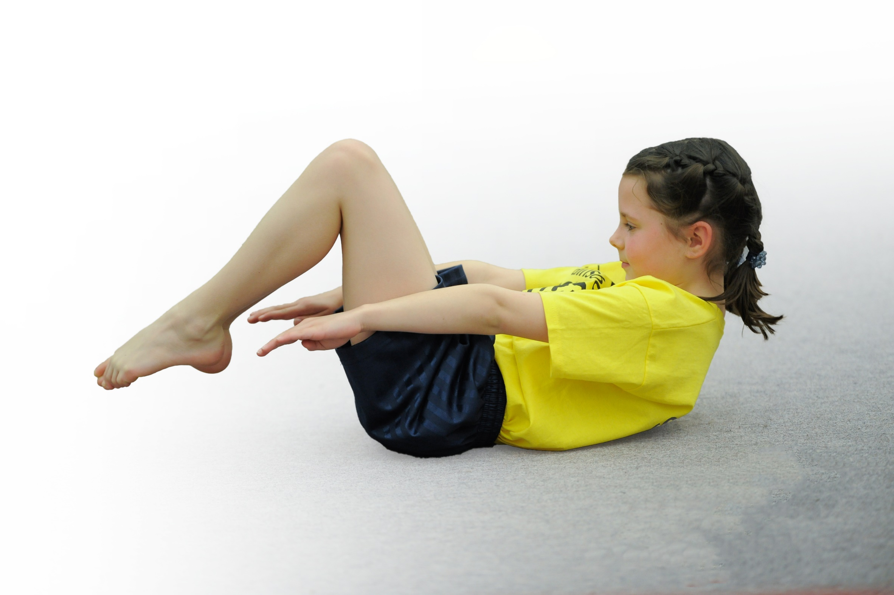
- build capacity and capability within the school to ensure that improvements made now will benefit pupils joining the school in future years

Please visit gov.uk for the revised DfE guidance including the 5 key indicators across which schools should demonstrate an improvement. This document will help you to review your provision and to report your spend. DfE encourages schools to use this template as an effective way of meeting the reporting requirements of the Primary PE and Sport Premium.

We recommend you start by reflecting on the impact of current provision and reviewing the previous spend.
Under the Ofsted Schools Inspection Framework, inspectors will assess how effectively leaders use
the Primary PE and Sport Premium and measure its impact on outcomes for pupils, and how effectively governors hold them to account
for this.

Schools are required to publish details of how they spend this funding as well as on the impact it has on pupils’ PE
and sport participation and attainment.
We recommend regularly updating the table and
publishing it on your website as evidence
of your ongoing review into how you are using the money
to secure maximum, sustainable impact. To see an example of how to complete the table please click HERE.

Support for review and reflection - considering the 5 key indicators from DfE, what development needs are a priority for your setting and your students now and why? Use the space below to reflect on previous spend, identify current need and priorities for the future.

Key achievements to date: | Areas for further improvement and baseline evidence of need:
Bronze and Silver Sainsbury’s School Games Mark.  Raising money for Sports Relief through week-long sports event.  Increased participation in sport throughout school, especially Pupil Premium and lower ability children, through offering a greater number of sporting opportunities to all children. We have also offered a broader range of sports to all pupils.  Increased confidence, knowledge and skills of staff teaching PE through attaining Real PE scheme and CPD for this.  2nd Place in the A league football and 1st Place in the Netball league 2016/17, Basketball Tupton Cluster winners 2017/18.  1st Place in Futsal event at EIS Sports Day run by Qualitas and 2nd place in Benchball. | To improve our sporting opportunities and participation in competitive sport for KS1 and KS2 children, especially through targeted extra-curricular clubs and school initiatives.  To continue to increase sporting participation for pupil premium and lower ability children through targeted interventions and increased sporting opportunities.  To ensure all our students receive at least 30 minutes of physical activity daily through new sporting initiatives at school.  Continue to raise the profile of PE and sport as a tool for whole school improvement.

Meeting national curriculum requirements for swimming and water safety | Please complete all of the below*:
What percentage of your current Year 6 cohort swim competently, confidently and proficiently over a distance of at least 25 metres? | %
What percentage of your current Year 6 cohort use a range of strokes effectively [for example, front crawl, backstroke and breaststroke]? | %
What percentage of your current Year 6 cohort perform safe self-rescue in different water-based situations? | %
Schools can choose to use the Primary PE and Sport Premium to provide additional provision for swimming but this must be for activity over and above the national curriculum requirements. Have you used it in this way? | Yes/No
*Schools may wish to provide this information in April, just before the publication deadline.

Action Plan and Budget Tracking
Capture your intended annual spend against the 5 key indicators. Clarify the success criteria and evidence of impact that you intend to measure to evaluate for students today and for the future.

Academic Year: 2018/19 | Total fund allocated: £18,000  Total spent: | Date Updated: September 2019
Key indicator 1: The engagement of all pupils in regular physical activity – Chief Medical Officer guidelines recommend that primary school children undertake at least 30 minutes of physical activity a day in school |  |  |  | Percentage of total allocation:
 |  |  |  | %
School focus with clarity on intended impact on pupils: | Actions to achieve: | Funding allocated: | Evidence and impact: | Sustainability and suggested next steps:
To develop the role of Sports Leaders and Bronze Ambassadors in school to encourage more children to take part in physical activities at lunch times.  Play Leaders to organise games and activities for children at lunchtime to increase their physical participation during this time. There will be a play leader on both the KS1 and KS2 playgrounds for the entire lunch hour.  Extra-curricular clubs provided at lunch time and after school to engage more children in physical activity and target PP and LA children.  Introduction of Golden Mile, as well as Active Maths activities created by PE Lead for KS1/KS2 and the use of Super Movers for KS1 to increase the amount of physical activity within the school day. | Training of Sports Leaders and Bronze Ambassadors provided by NEDSSP. Regular meeting with Sports Leaders to organize lunchtimes and a reward system for leaders.  Play leaders ensure equipment is set up and ready for start of lunch. They must ensure activities are varied throughout the week to keep children motivated and engaged.  Target children needed to be identified and targeted for certain clubs to ensure they are engaged in physical activity. Meetings with clubs provider (Premier Sports 2017/18, Qualitas 2018/19) to discuss how clubs are going and any changes needed to increase participation. Lunch staff informed of children having early lunch to maximize time spent being active.  Golden Mile introduced to children. Active Maths ideas and Super Movers introduced to staff in staff meeting and put on server to use at spare intervals during day. | Through NEDSSP (approx. £6500 altogether)  £5460  2 x 6hours per week.  £1695 Premier Sport  No cost. | Sports leaders lead an activity twice a week at lunch/break time for 30 minutes and children get involved in physical activity at lunch times.  Children, especially in KS1, are more engaged in physical activity at lunch times. Children noticeably enjoy the games being played.  Targeted children are participating in sport/physical activity for at least 30 minutes and lunch/after school.  Most children are engaging in 10 minutes of physical activity during the Golden Mile at lunch. Children enjoy doing the laps to music. | Train all new year 5s to ensure more children have a sense of responsibility at lunch times, encourage previous year 5s to help and take part in the lunch time activities.  Ensure Bronze Ambassadors are having regular meetings with JR to encourage impact on children’s physical activity levels.  Continue to provide lunch time/after school clubs which target PP/LA children. Plan lunch/after school clubs with Qualitas based on what children want to participate in (taken from whole school survey results).  Continue Daily Mile at lunch times and try introducing it to KS1 classes.  Introduce Active Maths ideas to staff ready for 2018/19 academic year.
Key indicator 2: The profile of PE and sport being raised across the school as a tool for whole school improvement |  |  |  | Percentage of total allocation:
 |  |  |  | %
School focus with clarity on intended impact on pupils: | Actions to achieve: | Funding allocated: | Evidence and impact: | Sustainability and suggested next steps:
To have a visit from an Olympian to inspire children and encourage them to take part in sports.  Real PE lessons introduced to teachers and children, which has had a positive impact on children’s attitudes to PE.  To have a notice board in school with sports news on that all children can see. Children are informed of what sports they can do on what days.  To include achievements of competitions and any sporting events in the celebrations assembly each week to raise awareness and encourage more students to want to take part. Achievements to also be included on new PE blog on website to keep parents informed and promote sporting achievement.  To ensure PE lead has release time in order to promote Sport and PE throughout the school and organise events for children to take part in more sport.  Sport Relief 2017/18 Daily Challenge promoted to engage children in fun activities that will motivate them to do more sport.  Inter-house competitions organised to promote different sports throughout the year for children to try and increase competitive experience of children.  Sports day organised to promote enjoyment through physical activity and competition.  Tupton World Cup organised to enhance children’s excitement for the competition and increase participation in football for KS1 and KS2.  Football trip to watch U17’s European internationals to engage children in competitive sport and promote excitement about participating in sport. | Arrange a visit from an Olympian using Sports for Schools and organize the day with all children and members of staff.  Introduction of Real PE scheme and CPD day for staff to enable them to teach it effectively.  Notice board set up on school PE display. Children reminded to look at this board and PE leader to keep this up to date.  PE leader to inform assembly leader each Friday of achievements, which are then read out weekly. Blog updated regularly by PE leader after competitions/sporting activities.  Head teacher to specify time for when PE lead can be released to organised any competitions/events to promote sport.  PE leader out every lunch time for 2 weeks promoting event and sent letters and messages to all parents/children promoting event. PE leader, alongside Sports leaders, to help make event happen.  Email sent out to all staff informing them of dates of competition. Children reminded of the competition in a Sports assembly on the week of competition. Year 6 Sports Leaders to run event for all year groups.  PE leader to send dates and activities to staff. Activities practiced by children before day. Parents informed by Newsletter and Sports letter.  PE leader to organise event and inform children in Sports assembly. PE lead to referee games at lunch times. Medals bought by PE leader and World Cup made in art lessons by Year 6 out of clay. Homework for teams to be created by PE leader and dojos given out.  Organise transport, tickets and staffing for game.  Send out letters to all KS2 children. | No funding.  £700 resources.  £600 CPD INSET day and any additional further CPD.  £100 for notice board.  No funding.  £500  + Supply costs.  No funding.  No funding.  £80 for all medals/certificates and new equipment needed.  No Funding.  ??? | Children from Reception to Year 6 took part in a PE session with an Olympic swimmer (James Kirton) and had a whole school assembly with an inspirational talk. Children were excited about the event and were inspired to take part in the sporting activities. This was evidenced through majority of students practicing sporting events with PE lead at lunch times on lead up to Olympic athlete coming in.  Following children questionnaires, children have praised the ‘Fun Station’ skills and games during lessons. Staff have also enjoyed teaching children the skills and games.  A display has been put up in school which is kept up to date with any big sporting events that have happened and the weekly mini leaders timetable. It is also used to promote PE and competitions.  Children enjoy sharing their achievements in assembly in front of their peers. It raises their confidence and promotes further sports participation, as children mentioned come back to play that sport again.  PE leader has had clear roles and has been able to plan timetables etc. effectively. The profile of PE has been raised through new ideas and activities organised.  All children took part in at least 2 events during the week. Children and staff were talking about sport and were generally excited to take part each day.  Children look forward to House competitions and staff see competitiveness of children come out as they aim to beat their peers in points.  Not completed yet.  Not completed yet.  Lots of children that went had never been to a competitive sporting event in their lives, so it enhanced their sporting experience. The children were all excited about watching sport. | Look into inviting more inspiring athletes into school to inspire children. Also, organise a variety of after school and lunch time clubs to take children’s inspiration and lead it to increased participation.  Continue to teach Real PE scheme (1 lesson a week). Teachers to be provided with CPD by PE lead if required and lessons to be observed to monitor the effectiveness of PE teaching.  Continue to keep notice board up to date with evidence of achievements and events coming up. Ensure all children know where this board is throughout the year.  Continue to praise achievements in Celebration assemblies, as well as introducing a PE blog on the website to further promote sport and ensure parents are kept up to date.  To continue to ensure PE leader has release time to organise sporting events and raise profile of PE. PE Policy to be reviewed.  Organise Sport Relief activities next year.  Organise more house events next year (once a half term). Continue to have them in afternoons as this has worked better. Encourage children to wear their house colours for competitions.  Organise more local sports trips that allow children to watch competitive sport at the top level.

Key indicator 3: Increased confidence, knowledge and skills of all staff in teaching PE and sport |  |  |  | Percentage of total allocation:
 |  |  |  | %
School focus with clarity on intended  impact on pupils: | Actions to achieve: | Funding  allocated: | Evidence and impact: | Sustainability and suggested  next steps:
Real PE scheme introduced to staff to improve their knowledge, skills and confidence in teaching PE, which in turn will improve PE enjoyment and achievement for children.  CPD folders/websites to be offered to staff for when they lack knowledge in certain sports. PE leader to also offer any support needed to staff. | Real PE INSET Training day and additional training offered for staff to feel confident in scheme. Resources given to staff and put on school system. Equipment bought for scheme by PE leader.  Location of CPD folders/websites to be emailed to all staff and PE leader to approach staff at start of each half term to ask if they require any support for their next sport on curriculum map. | £700 resources.  £600 CPD INSET day and any additional further CPD.  (stated above)  No funding. | From questioning staff, they feel much more confident in teaching PE.  Staff feel more confident in teaching PE with support readily available if required. Children receive high quality PE lessons throughout the year. | Continue to use Real PE scheme. Observe teachers during lessons to ensure effective teaching and offer feedback if needed. Ensure assessments are being used at the end of each unit.  Continue to offer CPD to staff if needed. Look into booking a lead practitioner (e.g. links from Chesterfield Football Club on behalf of Premier League Primary Stars) to work alongside teacher(s) if they feel they need extra support rather than just information from folders/PE leader.
Key indicator 4: Broader experience of a range of sports and activities offered to all pupils |  |  |  | Percentage of total allocation:
 |  |  |  | %
School focus with clarity on intended  impact on pupils: | Actions to achieve: | Funding  allocated: | Evidence and impact: | Sustainability and suggested  next steps:
To have a range of extra-curricular activities on offer for children, which will ensure we cater to the majority of interests and increase participation in sport.  Continue to use Real PE scheme games with children, which are alternative versions of popular games that will keep children interested in participation.  To attend a range of events/competitions through NEDSSP/Qualitas.  To have balance bike sessions for Reception children to improve confidence and skills when riding a bike.  Bikeability sessions for Y5 to increase their confidence and knowledge when riding on the roads. | Create links with Chesterfield Lawn Tennis Club to set up after school clubs and lessons for 6 weeks.  Contact Chesterfield Flight Basketball company to lead basketball lunch and after school clubs.  Contact and continue to hold links with Rugger Ed’s to lead lunch time and after school clubs.  Contact Premier Sports to run 3 lunch time clubs a week for half the year. Aim to choose a range of sports and alternate sports every 4 weeks to keep children interested.  Contact and continue links with Qualitas, who will run 3 lunch time and 3 after school clubs a week next year.  Teachers to use Real PE lesson plans once a week and play the game part of the lessons.  Organise staffing and transport to events/competitions. Send letters and encourage participation of events through individual interventions and assemblies.  Organise members of staff in KS1 to receive training on leading Balance Bike lessons. Set aside time in the hall timetable for these sessions to take place. Continue to offer opportunities for CPD to staff if needed.  Organise lead practitioners to come into school and deliver sessions.  Ensure children bring bikes in on correct dates for sessions. | ????  Not sure how much Qualitas are.  Funding for Real PE mentioned above.  NEDSSP £6500 approx.  Qualitas £1000.  Transport: ???  £634.54  £200 | Children have enjoyed the Tennis and Basketball clubs at the start of the year, however it seemed to be the same children going each week.  We found that paying for the Rugger Ed’s clubs as a school increased participation of children for after school clubs.  After questionnaires from children, we found they preferred to take part in more alternate sports. We therefore planned sports with Premier Sports that would encourage participation and enjoyment, such as archery and Boccia.  After talking to teachers and students, children seem to enjoy the games during lessons. There are lots of challenges that can be applied to the games to keep children interested.  Events attended through SSP:  Sports Hall athletics (Y3/4 and Y5/6), Multi-Sports (Y1/2), Football games (Y3-6), Girls football events x 3, Trampolining (Y5-6), Basketball competition, Dance Platform.  Events we will be attending:  Coleman Cup (football tournament), Tennis competition (Y3/4), Tag Rugby tournament (Y5/6) and EIS Sports Day (Y2/6). Participation in events has increased since previous years.  Children have all had a go at Balance Bike sessions and have increased their confidence and skill. Bikes offered to children during play and extra interventions given to children who need it.  Not completed yet. | Qualitas will lead 3 lunch time and 3 afterschool clubs a week throughout next year (2018/19), all paid for by school to encourage participation. These clubs have been targeted on what the children have said in the questionnaires and what they have really enjoyed this year.  We will ensure that the sports we are having during extra-curricular clubs will then lead into competitions lead by Qualitas against other schools.  Continue to use these games during lessons. Look into using some of their favourite games for Sports Leaders activities at lunch.  Continue to offer a range of events/competitions next year for children, targeting more events held for KS1.  Continue to offer Balance Bike sessions next year for Reception children.
Key indicator 5: Increased participation in competitive sport |  |  |  | Percentage of total allocation:
 |  |  |  | %
School focus with clarity on intended  impact on pupils: | Actions to achieve: | Funding  allocated: | Evidence and impact: | Sustainability and suggested  next steps:
To maintain a close relationship with NEDSSP/Qualitas so that PE leader is aware of competitions and events that will take place.  Continue to create links with local outside sporting organisations who provide competitive sporting opportunities, such as Rugger Ed’s, Chesterfield Lawn Tennis Club and Tupton Ivanhoes.  Organise House competitions to increase participation in competitive sport.  To continue to run a strong football team who take part in competitive games against other schools. | Attend regular PE meetings with Qualitas and identify which competitions we will be attending.  Send out letters for these events, sort transport and check them with our school diary.  Keep in contact with RuggerEd’s, Chesterfield Tennis Lawn Club and Tupton Ivanhoes, booking onto any competitive sporting opportunities that come up.  PE leader to organise events and let staff know. Y6 Sports leaders to run event.  PE leader to organise games between schools and to continue to run football training sessions each week. Teams need to be picked. | ???  No funding.  No funding.  No funding. Kit donated through Tupton Ivanhoes. | PE leader has attended regular meetings with SSP this year to ensure we know of all competitions on offer.  Over the course of the year, children will have had 14 different opportunities to take part in competitions.  Children will be taking part in a Tag Rugby tournament in the Summer term which will use skills that they learnt from the lunch time clubs earlier in the year.  The tennis House competition was successful and the results are displayed in a graph on the PE board. The Athletics House competition is planned for the Summer term.  Both A and B teams have improved throughout the year and have enjoyed successes. Both teams have had regular participation of a variety of children, and we have increase our girls playing football this year. | Working alongside Qualitas, we will look to increase our opportunities for KS1 children for competition. Qualitas have offered a greater number of competitions for next year, so we will look to enter the majority of them.  Continue to create links with any local clubs, as these will be easier for children to access to promote long-term participation.  Continue to organise House competitions and instill a competitive but fun atmostphere beween houses. Ensure more House competitions are organised for next year and that all children wear their house colours on the day of competitions.  Due to numbers, we will be looking to only have 1 team next year. We will look into getting a regular training session held afterschool, which will give children more time to play.

